HUSSAIN SHARIF SHAIK

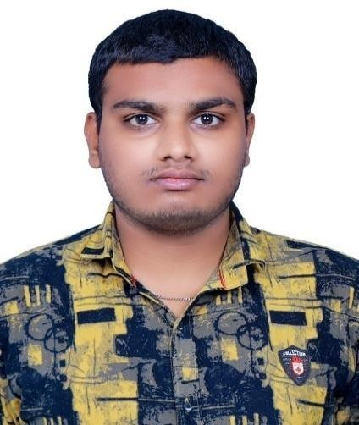

S/O AHAMAD ALI SHAIK

Email [ID:shaikhussain1562@gmail.com](mailto:shaikhussain1562@gmail.com) LinkedIn ID: Shaik Hussain Sharif Mobile: 6281105269

CAREER OBJECTIVES

To seek a challenging position in a Reputed Organization where my acquired technical, software and communication skills get utilized properly for ultimate career satisfaction and givemy best to the institution to help it in every possible way of its growth.

BASIC EDUCATION QUALIFICATIONS

|  |  |  |  |  |
| --- | --- | --- | --- | --- |
| Qualifications | Board/University | College Name | Year of Passing | Percentage |
| B-TECH (ECE) | Jawaharlal Nehru Technological University, Kakinada | Narasaraopeta Institute Of Technology, Narasaraopet | 2023  (Pursuing) | 70% |
| Inter (MPC) | Board of Intermediate AP | Bhavana Junior College, Narasaraopet | 2019 | 72.8% |
| SSC | Board of Secondary Education AP | Hindu High School, Narasaraopet | 2017 | 8.5  GPA |

TECHNICAL SKILLS

Programming Languages: C, Java, Python

MINI PROJECT

**Title :** TOUCH-LESS DOORBELL

**Role :** Team Leader

**Description :** This is one of the very interesting and much useful circuits in our real life named Automatic Doorbell Ranging System. If we install this automatic Doorbell using object detection circuit, the circuit will automatically sense the presence of the person and it rings thedoorbell.

**STRENGTHS**

* Flexibility and capability to work in environment.
* Good team player.

ACHIEVEMENTS

* Secured first prize in chess at school competitions
* Secured first prize at national level exams like NSO, NEO.
* Got second in technical quizze from my college
* Got first in power point Presentations from my college

EXTRA CURRICULAR ACTIVITIES

* Member of NSS
* Member of SWECHA
* Organized and participated in various number of workshops and webinars of SWECHA.
* Participated in workshops conducted by NITGLUG

CERTIFICATION

* C Programming
* Python Programming from Informatics Institutes,Narasaraopet
* Machine learning (Basic) from Udemy
* Facebook Ads Marketing fromUdemy
* NPTEL certification on Microprocessors and Interfacing-NPTEL

PERSONAL DETAILS

Name : Hussain Sharif Shaik

Father’s Name : Ahamad Ali Shaik

Date of Birth : 22-09-2002

Marital status : Single

Languages Known : Telugu, Hindi, English Nationality/Religion : Indian / Muslim

DECLARATION

All the information provided in this resume is true to the best of my knowledge and belief.

Place: NARASARAOPET

Date: 16/12/2022

(HUSSAIN SHARIF SHAIK)